Way Out West Roots Music Club

Management Committee Nomination Form 2025

This form must be used to nominate a Committee Member candidate

Nominations for the Annual General Meeting to be held at Newport Bowling Club on November 21st at 6pm at the Newport bowls club

Nominations must be received by the club secretary prior to the meeting or presented at the meeting.

Completed forms to be emailed to club secretary [jennybrockman29@gmail.com](mailto:jennybrockman29@gmail.com)

No signature is required but fill in all details of nominee and seconder

I wish to nominate this person (print name below)

For the position of:

On the Way Out West Roots Music Club Committee

Nominated by:

Signed: __________________________________

Seconded by: Print

Signed: ______________________________________________

CONSENT of CANDIDATE:  
I hereby advise secretary of my consent to this nomination

Candidate’s name:

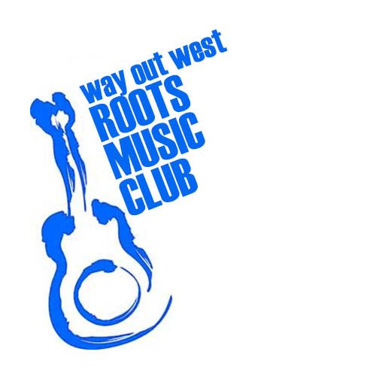

Signed: ______________________________________

Date: __________________